Introduction to Data Management

By Bhavna Kaparaju (bgk378), Brett Nesfeder (bmn644), Callie Gilmore (cgg756), and Dawson Cook (dcc2436)

Final Project - The Home Depot

# **The Home Depot Background & Data Strategy**

The Home Depot is the largest home improvement retailer in America. They supply tools, construction products, and home improvement services. It was founded in 1978 in Atlanta, Georgia and now has 2,278 stores across North America. With many stores and locations, The Home Depot deals with a huge amount of data on a daily basis.

We thought an offensive data strategy would be best for The Home Depot. An offensive data strategy would be optimal for The Home Depot since they are a retail store with big competitors such as Lowe’s, Walmart and Amazon. This also suits The Home Depot well because the data they would be using would be flexible and would allow them to create multiple versions of the truth. By implementing this offensive strategy, The Home Depot would be supporting revenue growth and generating customer insights in order to keep up with the competition. The strategy would also help with managerial decisions and overall make The Home Depot’s data management system much more effective.

# **Transactional Management Applications ERDs**

For our project, we chose The Home Depot as our organization. From this we decided on our 3 transactional management applications as Customer Point of Sale, Inventory and Wholesale purchasing. We chose these 3 as we believe that are important components in The Home Depot’s daily business operations.

## Customer Point of Sale ERD

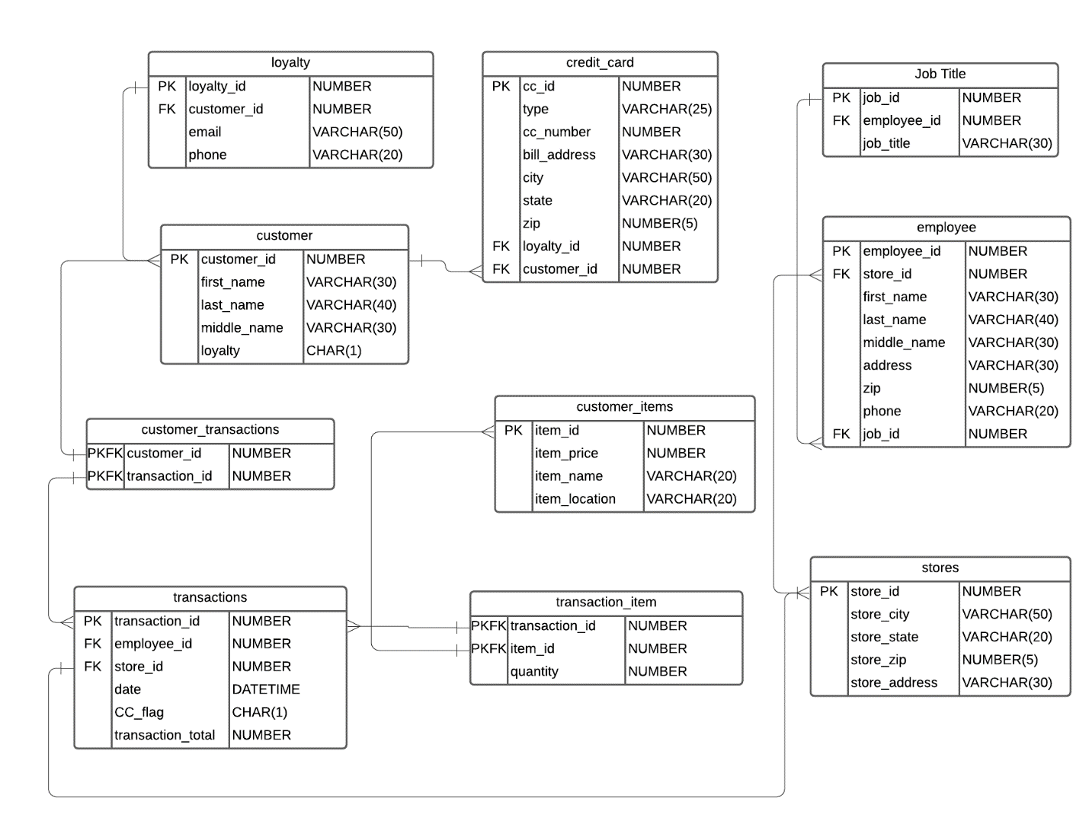

## Inventory ERD

## Wholesale Purchasing ERD

# **Transactional Management Applications DDL**

## Customer DDL

--drop sequences

DROP SEQUENCE c_customer_id_seq;

DROP SEQUENCE c_loyalty_id_seq;

DROP SEQUENCE c_cc_id_seq;

DROP SEQUENCE c_transactions_id_seq;

DROP SEQUENCE c_customer_itemid_seq;

DROP SEQUENCE c_storeid_seq;

DROP SEQUENCE c_employee_id_seq;

DROP SEQUENCE c_job_id_seq;

--drop views

DROP VIEW transaction_item_view;

DROP VIEW customer_transactions_view;

DROP VIEW credit_card_view;

DROP VIEW loyalty_view;

DROP VIEW customer_view;

DROP VIEW transactions_view;

DROP VIEW customer_items_view;

DROP VIEW employee_view;

DROP VIEW job_title_view;

DROP VIEW customer_stores_view;

--drop tables

DROP TABLE transaction_item;

DROP TABLE customer_transactions;

DROP TABLE credit_card;

DROP TABLE loyalty;

DROP TABLE customer;

DROP TABLE transactions;

DROP TABLE customer_items;

DROP TABLE employee;

DROP TABLE job_title;

DROP TABLE customer_stores;

--sequence for customer_id

CREATE SEQUENCE c_customer_id_seq

START WITH 1 INCREMENT BY 1;

--sequence for loyalty

CREATE SEQUENCE c_loyalty_id_seq

START WITH 10 INCREMENT BY 1;

--sequence for cc_id

CREATE SEQUENCE c_cc_id_seq

START WITH 100 INCREMENT BY 1;

--sequence for transaction_id

CREATE SEQUENCE c_transactions_id_seq

START WITH 1000 INCREMENT BY 1;

--sequence for item_id

CREATE SEQUENCE c_customer_itemid_seq

START WITH 1000 INCREMENT BY 1;

--sequence for store_id

CREATE SEQUENCE c_storeid_seq

START WITH 2000 INCREMENT BY 1;

--sequence for employee_id

CREATE SEQUENCE c_employee_id_seq

START WITH 1000 INCREMENT BY 1;

--sequence for job_id

CREATE SEQUENCE c_job_id_seq

START WITH 1000 INCREMENT BY 1;

--create tables

CREATE TABLE customer

(

customer_id NUMBER DEFAULT c_customer_id_seq.NEXTVAL PRIMARY KEY,

first_name VARCHAR(30) NOT NULL,

middle_name VARCHAR(30),

last_name VARCHAR(40) NOT NULL,

loyalty CHAR(1) NOT NULL

);

CREATE TABLE loyalty

(

loyalty_id NUMBER DEFAULT c_loyalty_id_seq.NEXTVAL PRIMARY KEY,

customer_id NUMBER REFERENCES customer(customer_id),

email VARCHAR(50) UNIQUE,

phone VARCHAR(20) NOT NULL

);

CREATE TABLE credit_card

(

cc_id NUMBER DEFAULT c_cc_id_seq.NEXTVAL PRIMARY KEY,

loyalty_id NUMBER REFERENCES loyalty (loyalty_id),

customer_id NUMBER REFERENCES customer (customer_id),

card_type VARCHAR(25) NOT NULL,

card_num VARCHAR(16) NOT NULL,

billing_address VARCHAR(30) NOT NULL,

city VARCHAR(50) NOT NULL,

state VARCHAR(20) NOT NULL,

zip NUMBER(5) NOT NULL

);

CREATE TABLE transactions

(

transactions_id NUMBER DEFAULT c_transactions_id_seq.NEXTVAL PRIMARY KEY,

transaction_date DATE NOT NULL,

credit_flag CHAR(1) NOT NULL,

transaction_total NUMBER NOT NULL

);

CREATE TABLE customer_transactions

(

customer_id NUMBER REFERENCES customer (customer_id),

transactions_id NUMBER REFERENCES transactions (transactions_id),

CONSTRAINT c_customer_transaction_cpk PRIMARY KEY (customer_id, transactions_id)

);

CREATE TABLE customer_items

(

item_id NUMBER DEFAULT c_customer_itemid_seq.NEXTVAL PRIMARY KEY,

item_price NUMBER NOT NULL,

item_name VARCHAR(20) NOT NULL,

item_description VARCHAR(100) NOT NULL,

item_location VARCHAR(20) NOT NULL

);

CREATE TABLE transaction_item

(

transactions_id NUMBER REFERENCES transactions (transactions_id),

item_id NUMBER REFERENCES customer_items (item_id),

CONSTRAINT c_transaction_item_cpk PRIMARY KEY (transactions_id,item_id),

quantity NUMBER NOT NULL

);

CREATE TABLE customer_stores

(

store_id NUMBER DEFAULT c_storeid_seq.NEXTVAL NOT NULL PRIMARY KEY,

store_city VARCHAR(50) NOT NULL,

store_state VARCHAR(20) NOT NULL,

store_zip NUMBER(5) NOT NULL,

store_address VARCHAR(30) NOT NULL

);

CREATE TABLE job_title

(

job_id NUMBER DEFAULT c_job_id_seq.NEXTVAL PRIMARY KEY,

job_title VARCHAR(30)

);

CREATE TABLE employee

(

employee_id NUMBER DEFAULT c_employee_id_seq.NEXTVAL PRIMARY KEY,

store_id NUMBER REFERENCES customer_stores (store_id),

first_name VARCHAR(30) NOT NULL,

last_name VARCHAR(40) NOT NULL,

middle_name VARCHAR(30),

address VARCHAR(30) NOT NULL,

zip NUMBER(5) NOT NULL,

phone VARCHAR(20) NOT NULL,

job_id NUMBER REFERENCES job_title (job_id)

);

CREATE OR REPLACE VIEW transaction_item_view

AS SELECT *

FROM transaction_item;

CREATE OR REPLACE VIEW customer_transactions_view

AS SELECT *

FROM customer_transactions;

CREATE OR REPLACE VIEW credit_card_view

AS SELECT *

FROM credit_card;

CREATE OR REPLACE VIEW loyalty_view

AS SELECT *

FROM loyalty;

CREATE OR REPLACE VIEW customer_view

AS SELECT *

FROM customer;

CREATE OR REPLACE VIEW transactions_view

AS SELECT *

FROM transactions;

CREATE OR REPLACE VIEW customer_items_view

AS SELECT *

FROM customer_items;

CREATE OR REPLACE VIEW employee_view

AS SELECT *

FROM employee;

CREATE OR REPLACE VIEW job_title_view

AS SELECT *

FROM job_title;

CREATE OR REPLACE VIEW customer_stores_view

AS SELECT *

FROM customer_stores;

--insert statements

INSERT INTO customer

(first_name, middle_name, last_name, loyalty)

VALUES('Jeffrey', 'John', 'Jacobs', 'Y');

INSERT INTO customer_items

(item_price, item_name, item_description, item_location)

VALUES (20, 'Wood plank', 'plank of wood', 'Aisle 14');

INSERT INTO loyalty

(customer_id, email, phone)

VALUES(1, 'jjj@gmail.com', '5126780965');

INSERT INTO credit_card

(loyalty_id, customer_id, card_type, card_num, billing_address, city, state, zip)

VALUES(10, 1, 'Visa', '0000111122223333', '100 House Ave', 'Los Angeles', 'CA', 78735);

INSERT INTO transactions

(transaction_date, credit_flag, transaction_total)

VALUES('25-JUN-20', 'Y', 6000);

INSERT INTO customer_transactions

(customer_id, transactions_id)

VALUES(1, 1000);

INSERT INTO job_title

(job_title)

VALUES('Manager');

INSERT INTO customer_stores

(store_address, store_city, store_state, store_zip)

VALUES ('1200 Home Depot Blvd', 'Los Angeles', 'California', 90210);

INSERT INTO employee

(store_id, first_name, last_name, middle_name, address, zip, phone, job_id)

VALUES(2000, 'Pete', 'Plunker', 'Patrick', '23 Champion Dr', 90210, '5126157824', 1000);

INSERT INTO transaction_item

(transactions_id, item_id, quantity)

VALUES(1000, 1000, 2);

COMMIT;

## Inventory DDL

--drop sequences

DROP SEQUENCE i_inventory_itemid_sequence;

DROP SEQUENCE i_depid_sequence;

DROP SEQUENCE i_storeid_sequence;

--drop views

DROP VIEW store_items_view;

DROP VIEW department_items_view;

DROP VIEW department_view;

DROP VIEW inventory_stores_view;

DROP VIEW inventory_items_view;

--drop tables

DROP TABLE store_items;

DROP TABLE department_items;

DROP TABLE department;

DROP TABLE inventory_stores;

DROP TABLE inventory_items;

--sequence for items_id

CREATE SEQUENCE i_inventory_itemid_sequence

START WITH 1000

INCREMENT BY 1;

--sequence for department_ids

CREATE SEQUENCE i_depid_sequence

START WITH 1000

INCREMENT BY 1;

--sequence for store_ids

CREATE SEQUENCE i_storeid_sequence

START WITH 1000

INCREMENT BY 1;

--create tables

CREATE TABLE inventory_items

(

item_id NUMBER DEFAULT i_inventory_itemid_sequence.NEXTVAL NOT NULL PRIMARY KEY,

item_name VARCHAR(30) NOT NULL,

item_description VARCHAR(100) NOT NULL,

item_quantity NUMBER NOT NULL,

item_restock CHAR(1) NOT NULL

);

CREATE TABLE inventory_stores

(

store_id NUMBER DEFAULT i_storeid_sequence.NEXTVAL NOT NULL PRIMARY KEY,

store_address VARCHAR(30) NOT NULL,

store_city VARCHAR(40) NOT NULL,

store_state VARCHAR(20) NOT NULL,

store_zip NUMBER(5) NOT NULL

);

CREATE TABLE department

(

department_id NUMBER DEFAULT i_depid_sequence.NEXTVAL NOT NULL PRIMARY KEY,

department_name VARCHAR(30) NOT NULL

);

CREATE TABLE store_items

(

store_id NUMBER NOT NULL,

item_id NUMBER NOT NULL,

CONSTRAINT i_store_item_pck PRIMARY KEY (store_id, item_id),

CONSTRAINT i_store_id_fk FOREIGN KEY (store_id) REFERENCES inventory_stores(store_id),

CONSTRAINT i_item_store_id_fk FOREIGN KEY (item_id) REFERENCES inventory_items(item_id)

);

CREATE TABLE department_items

(

department_id NUMBER NOT NULL,

item_id NUMBER NOT NULL,

CONSTRAINT i_department_item_pck PRIMARY KEY (department_id, item_id),

CONSTRAINT i_department_id_fk FOREIGN KEY (department_id) REFERENCES department(department_id),

CONSTRAINT i_item_dep_id_fk FOREIGN KEY (item_id) REFERENCES inventory_items(item_id)

);

CREATE OR REPLACE VIEW store_items_view

AS SELECT *

FROM store_items;

CREATE OR REPLACE VIEW department_items_view

AS SELECT *

FROM department_items;

CREATE OR REPLACE VIEW department_view

AS SELECT *

FROM department;

CREATE OR REPLACE VIEW inventory_stores_view

AS SELECT *

FROM inventory_stores;

CREATE OR REPLACE VIEW inventory_items_view

AS SELECT *

FROM inventory_items;

--Inserts

INSERT INTO inventory_items

(item_name, item_description, item_quantity, item_restock)

VALUES ('Nest Hello Video Doorbell', 'A wired video doorbell', '50', 'N');

INSERT INTO inventory_stores

(store_address, store_city, store_state, store_zip)

VALUES ('1200 Home Depot Blvd', 'Los Angeles', 'California', 90210);

INSERT INTO department

(department_name)

VALUES ('Doorbells');

INSERT INTO store_items

(store_id, item_id)

VALUES ('1000', '1000');

INSERT INTO department_items

(department_id, item_id)

VALUES ('1000', '1000');

COMMIT;

## Wholesale Purchasing DDL

--drop sequences

DROP SEQUENCE w_wholesaleitemid_sequence;

DROP SEQUENCE w_orderid_sequence;

DROP SEQUENCE w_storeid_sequence;

DROP SEQUENCE w_vendorid_sequence;

DROP SEQUENCE w_managerid_sequence;

--drop views

DROP VIEW item_order_view;

DROP VIEW orders_view;

DROP VIEW vendors_view;

DROP VIEW purchase_manager_view;

DROP VIEW wholesale_stores_view;

DROP VIEW wholesale_items_view;

--drop tables

DROP TABLE item_order;

DROP TABLE orders;

DROP TABLE vendors;

DROP TABLE purchase_manager;

DROP TABLE wholesale_stores;

DROP TABLE wholesale_items;

--sequence for items_id

CREATE SEQUENCE w_wholesaleitemid_sequence

START WITH 1000

INCREMENT BY 1;

--sequence for order_ids

CREATE SEQUENCE w_orderid_sequence

START WITH 1000

INCREMENT BY 1;

--sequence for store_ids

CREATE SEQUENCE w_storeid_sequence

START WITH 3000

INCREMENT BY 1;

--sequence for vendor_ids

CREATE SEQUENCE w_vendorid_sequence

START WITH 1000

INCREMENT BY 1;

--sequence for manager_ids

CREATE SEQUENCE w_managerid_sequence

START WITH 1000

INCREMENT BY 1;

--create tables

CREATE TABLE wholesale_items

(

item_id NUMBER DEFAULT w_wholesaleitemid_sequence.NEXTVAL NOT NULL PRIMARY KEY,

item_name VARCHAR(30) NOT NULL,

item_description VARCHAR(100) NOT NULL,

item_price NUMBER NOT NULL

);

CREATE TABLE wholesale_stores

(

store_id NUMBER DEFAULT w_storeid_sequence.NEXTVAL NOT NULL PRIMARY KEY,

store_city VARCHAR(40) NOT NULL,

store_state VARCHAR(20) NOT NULL,

store_zip NUMBER(5) NOT NULL,

store_address VARCHAR(30) NOT NULL

);

CREATE TABLE purchase_manager

(

manager_id NUMBER DEFAULT w_managerid_sequence.NEXTVAL NOT NULL PRIMARY KEY,

manager_firstname VARCHAR(30) NOT NULL,

manager_middlename VARCHAR(30) NOT NULL,

manager_lastname VARCHAR(30) NOT NULL,

store_id NUMBER NOT NULL,

CONSTRAINT w_store_id_manager_fk FOREIGN KEY (store_id) REFERENCES wholesale_stores(store_id)

);

CREATE TABLE vendors

(

vendor_id NUMBER DEFAULT w_vendorid_sequence.NEXTVAL NOT NULL PRIMARY KEY,

vendor_name VARCHAR(30) NOT NULL,

vendor_address VARCHAR(30) NOT NULL,

vendor_city VARCHAR(40) NOT NULL,

vendor_state VARCHAR(20) NOT NULL,

vendor_zip NUMBER(5) NOT NULL,

vendor_contact_name VARCHAR(50) NOT NULL,

vendor_contact_phone VARCHAR(12) NOT NULL,

vendor_contact_email VARCHAR(50) NOT NULL UNIQUE

);

CREATE TABLE orders

(

order_id NUMBER DEFAULT w_orderid_sequence.NEXTVAL NOT NULL PRIMARY KEY,

order_date_time DATE NOT NULL,

order_total NUMBER NOT NULL,

manager_id NUMBER NOT NULL,

store_id NUMBER NOT NULL,

vendor_id NUMBER NOT NULL,

CONSTRAINT w_store_id_order_fk FOREIGN KEY (store_id) REFERENCES wholesale_stores(store_id),

CONSTRAINT w_manager_id_order_fk FOREIGN KEY (manager_id) REFERENCES purchase_manager(manager_id),

CONSTRAINT w_vendor_id_order_fk FOREIGN KEY (vendor_id) REFERENCES vendors(vendor_id)

);

CREATE TABLE item_order

(

order_id NUMBER NOT NULL,

item_id NUMBER NOT NULL,

quantity NUMBER NOT NULL,

CONSTRAINT w_order_id_itemorder_fk FOREIGN KEY (order_id) REFERENCES orders(order_id),

CONSTRAINT w_item_id_itemorder_fk FOREIGN KEY (item_id) REFERENCES wholesale_items(item_id)

);

CREATE OR REPLACE VIEW item_order_view

AS SELECT *

FROM item_order;

CREATE OR REPLACE VIEW orders_view

AS SELECT *

FROM orders;

CREATE OR REPLACE VIEW vendors_view

AS SELECT *

FROM vendors;

CREATE OR REPLACE VIEW purchase_manager_view

AS SELECT *

FROM purchase_manager;

CREATE OR REPLACE VIEW wholesale_stores_view

AS SELECT *

FROM wholesale_stores;

CREATE OR REPLACE VIEW wholesale_items_view

AS SELECT *

FROM wholesale_items;

--Inserts

INSERT INTO wholesale_items

(item_name, item_description, item_price)

VALUES ('Lamp', 'Rainbow Colorful Lamp', 100);

INSERT INTO wholesale_stores

(store_address, store_city, store_state, store_zip)

VALUES ('1300 Home Depot Ave', 'Los Angeles', 'California', 88746);

INSERT INTO purchase_manager

(manager_firstname, manager_middlename, manager_lastname, store_id)

VALUES ('Jeff', 'Keith', 'Adams', 3000);

INSERT INTO vendors

(vendor_name, vendor_address, vendor_city, vendor_state, vendor_zip, vendor_contact_name, vendor_contact_phone, vendor_contact_email)

VALUES ('Lamps Inc', '101 Bunny Run', 'Los Angeles', 'California', '90210', 'Bob Roberts', '7816549087', 'bob.roberts@gmail.com');

INSERT INTO orders

(order_date_time, order_total, manager_id, store_id, vendor_id)

VALUES ('25-SEP-14', 4000, 1000, 3000, 1000);

INSERT INTO item_order

(order_id, item_id, quantity)

VALUES (1000, 1000, 200);

COMMIT;

# **Data Warehouse**

## Data Warehouse ERD

## Data Warehouse DDL

--drop sequences

DROP SEQUENCE dw_inventory_itemid_sequence;

DROP SEQUENCE dw_depid_sequence;

DROP SEQUENCE dw_storeid_sequence;

DROP SEQUENCE dw_customer_id_seq;

DROP SEQUENCE dw_loyalty_id_seq;

DROP SEQUENCE dw_cc_id_seq;

DROP SEQUENCE dw_transactions_id_seq;

DROP SEQUENCE dw_customer_itemid_sequence;

DROP SEQUENCE dw_employee_id_seq;

DROP SEQUENCE dw_job_id_seq;

DROP SEQUENCE dw_wholesaleitemid_sequence;

DROP SEQUENCE dw_orderid_sequence;

--DROP SEQUENCE dw_storeid_sequence;

DROP SEQUENCE dw_vendorid_sequence;

DROP SEQUENCE dw_managerid_sequence;

--drop tables

DROP TABLE transaction_item_dw;

DROP TABLE customer_transactions_dw;

DROP TABLE item_order_dw;

DROP TABLE department_items_dw;

DROP TABLE orders_dw;

DROP TABLE store_items_dw;

DROP TABLE department_dw;

DROP TABLE inventory_items_dw;

DROP TABLE credit_card_dw;

DROP TABLE loyalty_dw;

DROP TABLE customer_dw;

DROP TABLE wholesale_items_dw;

DROP TABLE employee_dw;

DROP TABLE job_title_dw;

DROP TABLE transactions_dw;

DROP TABLE customer_items_dw;

DROP TABLE vendors_dw;

DROP TABLE purchase_manager_dw;

DROP TABLE stores_dw;

DROP PROCEDURE final_etl_proc;

--create sequences

CREATE SEQUENCE dw_inventory_itemid_sequence

START WITH 1000

INCREMENT BY 1;

--sequence for department_ids

CREATE SEQUENCE dw_depid_sequence

START WITH 1000

INCREMENT BY 1;

--sequence for store_ids

CREATE SEQUENCE dw_storeid_sequence

START WITH 1002

INCREMENT BY 1;

CREATE SEQUENCE dw_customer_id_seq

START WITH 1 INCREMENT BY 1;

--sequence for loyalty

CREATE SEQUENCE dw_loyalty_id_seq

START WITH 10 INCREMENT BY 1;

--sequence for cc_id

CREATE SEQUENCE dw_cc_id_seq

START WITH 100 INCREMENT BY 1;

--sequence for transaction_id

CREATE SEQUENCE dw_transactions_id_seq

START WITH 1000 INCREMENT BY 1;

--sequence for item_id

CREATE SEQUENCE dw_customer_itemid_sequence

START WITH 1000 INCREMENT BY 1;

--sequence for employee_id

CREATE SEQUENCE dw_employee_id_seq

START WITH 1000 INCREMENT BY 1;

--sequence for job_id

CREATE SEQUENCE dw_job_id_seq

START WITH 1000 INCREMENT BY 1;

--sequence for items_id

CREATE SEQUENCE dw_wholesaleitemid_sequence

START WITH 1000

INCREMENT BY 1;

--sequence for order_ids

CREATE SEQUENCE dw_orderid_sequence

START WITH 1000

INCREMENT BY 1;

--sequence for vendor_ids

CREATE SEQUENCE dw_vendorid_sequence

START WITH 1000

INCREMENT BY 1;

--sequence for manager_ids

CREATE SEQUENCE dw_managerid_sequence

START WITH 1000

INCREMENT BY 1;

--create tables

CREATE TABLE inventory_items_dw

(

item_id NUMBER DEFAULT dw_inventory_itemid_sequence.NEXTVAL NOT NULL PRIMARY KEY,

item_name VARCHAR(30) NOT NULL,

item_description VARCHAR(100) NOT NULL,

item_quantity NUMBER NOT NULL,

item_restock CHAR(1) NOT NULL

);

CREATE TABLE stores_dw

(

store_id NUMBER DEFAULT dw_storeid_sequence.NEXTVAL NOT NULL PRIMARY KEY,

store_city VARCHAR(40) NOT NULL,

store_state VARCHAR(20) NOT NULL,

store_zip NUMBER(5) NOT NULL,

store_address VARCHAR(30) NOT NULL

);

CREATE TABLE department_dw

(

department_id NUMBER DEFAULT dw_depid_sequence.NEXTVAL NOT NULL PRIMARY KEY,

department_name VARCHAR(30) NOT NULL

);

CREATE TABLE store_items_dw

(

store_id NUMBER NOT NULL,

item_id NUMBER NOT NULL,

CONSTRAINT dw_store_item_pck PRIMARY KEY (store_id, item_id),

CONSTRAINT dw_store_id_fk FOREIGN KEY (store_id) REFERENCES stores_dw(store_id),

CONSTRAINT dw_item_store_id_fk FOREIGN KEY (item_id) REFERENCES inventory_items_dw(item_id)

);

CREATE TABLE department_items_dw

(

department_id NUMBER NOT NULL,

item_id NUMBER NOT NULL,

CONSTRAINT dw_department_item_pck PRIMARY KEY (department_id, item_id),

CONSTRAINT dw_department_id_fk FOREIGN KEY (department_id) REFERENCES department_dw(department_id),

CONSTRAINT dw_item_dep_id_fk FOREIGN KEY (item_id) REFERENCES inventory_items_dw(item_id)

);

CREATE TABLE customer_dw

(

customer_id NUMBER DEFAULT dw_customer_id_seq.NEXTVAL PRIMARY KEY,

first_name VARCHAR(30) NOT NULL,

middle_name VARCHAR(30),

last_name VARCHAR(40) NOT NULL,

loyalty CHAR(1) NOT NULL

);

CREATE TABLE loyalty_dw

(

loyalty_id NUMBER DEFAULT dw_loyalty_id_seq.NEXTVAL PRIMARY KEY,

customer_id NUMBER REFERENCES customer_dw(customer_id),

email VARCHAR(50) UNIQUE,

phone VARCHAR(20) NOT NULL

);

CREATE TABLE credit_card_dw

(

cc_id NUMBER DEFAULT dw_cc_id_seq.NEXTVAL PRIMARY KEY,

loyalty_id NUMBER REFERENCES loyalty_dw (loyalty_id),

customer_id NUMBER REFERENCES customer_dw (customer_id),

card_type VARCHAR(25) NOT NULL,

card_num VARCHAR(16) NOT NULL,

billing_Address VARCHAR(30) NOT NULL,

city VARCHAR(50) NOT NULL,

state VARCHAR(20) NOT NULL,

zip NUMBER(5) NOT NULL

);

CREATE TABLE transactions_dw

(

transactions_id NUMBER DEFAULT dw_transactions_id_seq.NEXTVAL PRIMARY KEY,

transaction_date TIMESTAMP NOT NULL,

credit_flag CHAR(1) NOT NULL,

transaction_total NUMBER NOT NULL

);

CREATE TABLE customer_transactions_dw

(

customer_id NUMBER REFERENCES customer_dw (customer_id),

transactions_id NUMBER REFERENCES transactions_dw (transactions_id),

CONSTRAINT dw_customer_transaction_cpk PRIMARY KEY (customer_id, transactions_id)

);

CREATE TABLE customer_items_dw

(

item_id NUMBER DEFAULT dw_customer_itemid_sequence.NEXTVAL PRIMARY KEY,

item_price NUMBER NOT NULL,

item_name VARCHAR(20) NOT NULL,

item_description VARCHAR(100) NOT NULL,

item_location VARCHAR(20) NOT NULL

);

CREATE TABLE transaction_item_dw

(

transactions_id NUMBER REFERENCES transactions_dw (transactions_id),

item_id NUMBER REFERENCES customer_items_dw (item_id),

CONSTRAINT dw_transaction_item_cpk PRIMARY KEY (transactions_id,item_id),

quantity NUMBER NOT NULL

);

CREATE TABLE job_title_dw

(

job_id NUMBER DEFAULT dw_job_id_seq.NEXTVAL PRIMARY KEY,

job_title VARCHAR(30)

);

CREATE TABLE employee_dw

(

employee_id NUMBER DEFAULT dw_employee_id_seq.NEXTVAL PRIMARY KEY,

store_id NUMBER REFERENCES stores_dw (store_id),

first_name VARCHAR(30) NOT NULL,

last_name VARCHAR(40) NOT NULL,

middle_name VARCHAR(30),

address VARCHAR(30) NOT NULL,

zip NUMBER(5) NOT NULL,

phone VARCHAR(20) NOT NULL,

job_id NUMBER REFERENCES job_title_dw (job_id)

);

CREATE TABLE wholesale_items_dw

(

item_id NUMBER DEFAULT dw_wholesaleitemid_sequence.NEXTVAL NOT NULL PRIMARY KEY,

item_name VARCHAR(30) NOT NULL,

item_description VARCHAR(100) NOT NULL,

item_price NUMBER NOT NULL

);

CREATE TABLE purchase_manager_dw

(

manager_id NUMBER DEFAULT dw_managerid_sequence.NEXTVAL NOT NULL PRIMARY KEY,

manager_firstname VARCHAR(30) NOT NULL,

manager_middlename VARCHAR(30) NOT NULL,

manager_lastname VARCHAR(30) NOT NULL,

store_id NUMBER NOT NULL,

CONSTRAINT dw_store_id_purchase_manager_fk FOREIGN KEY (store_id) REFERENCES stores_dw(store_id)

);

CREATE TABLE vendors_dw

(

vendor_id NUMBER DEFAULT dw_vendorid_sequence.NEXTVAL NOT NULL PRIMARY KEY,

vendor_name VARCHAR(30) NOT NULL,

vendor_address VARCHAR(30) NOT NULL,

vendor_city VARCHAR(40) NOT NULL,

vendor_state VARCHAR(20) NOT NULL,

vendor_zip NUMBER(5) NOT NULL,

vendor_contact_name VARCHAR(50) NOT NULL,

vendor_contact_phone VARCHAR(12) NOT NULL,

vendor_contact_email VARCHAR(50) NOT NULL UNIQUE

);

CREATE TABLE orders_dw

(

order_id NUMBER DEFAULT dw_orderid_sequence.NEXTVAL NOT NULL PRIMARY KEY,

order_date_time DATE NOT NULL,

order_total NUMBER NOT NULL,

manager_id NUMBER NOT NULL,

store_id NUMBER NOT NULL,

vendor_id NUMBER NOT NULL,

CONSTRAINT dw_store_id_orderdw_fk FOREIGN KEY (store_id) REFERENCES stores_dw(store_id),

CONSTRAINT dw_manager_id_orderdw_fk FOREIGN KEY (manager_id) REFERENCES purchase_manager_dw(manager_id),

CONSTRAINT dw_vendor_id_orderdw_fk FOREIGN KEY (vendor_id) REFERENCES vendors_dw(vendor_id)

);

CREATE TABLE item_order_dw

(

order_id NUMBER NOT NULL,

item_id NUMBER NOT NULL,

quantity NUMBER NOT NULL,

CONSTRAINT dw_order_id_itemorderdw_fk FOREIGN KEY (order_id) REFERENCES orders_dw(order_id),

CONSTRAINT dw_item_id_itemorderdw_fk FOREIGN KEY (item_id) REFERENCES wholesale_items_dw(item_id)

);

# **ETL Process**

DROP PROCEDURE final_etl_proc;

CREATE PROCEDURE final_etl_proc

AS

BEGIN

MERGE INTO inventory_items_dw i_i_dw

USING inventory_items_view i_i

ON (i_i_dw.item_id = i_i.item_id)

WHEN MATCHED THEN

UPDATE SET i_i_dw.item_name = i_i.item_name, i_i_dw.item_description = i_i.item_description, i_i_dw.item_quantity = i_i.item_quantity, i_i_dw.item_restock = i_i.item_restock;

INSERT INTO inventory_items_dw

SELECT *

FROM inventory_items_view

WHERE NOT EXISTS (

SELECT *

FROM inventory_items_dw

WHERE inventory_items_dw.item_id = inventory_items_view.item_id);

MERGE INTO stores_dw s_dw

USING customer_stores_view csv

ON (s_dw.store_id = csv.store_id)

WHEN MATCHED THEN

UPDATE SET s_dw.store_city = csv.store_city, s_dw.store_state = csv.store_state, s_dw.store_zip = csv.store_zip, s_dw.store_address = csv.store_address;

MERGE INTO stores_dw s_dw

USING inventory_stores_view isv

ON (s_dw.store_id = isv.store_id)

WHEN MATCHED THEN

UPDATE SET s_dw.store_city = isv.store_city, s_dw.store_state = isv.store_state, s_dw.store_zip = isv.store_zip, s_dw.store_address = isv.store_address;

MERGE INTO stores_dw s_dw

USING wholesale_stores_view wsv

ON (s_dw.store_id = wsv.store_id)

WHEN MATCHED THEN

UPDATE SET s_dw.store_city = wsv.store_city, s_dw.store_state = wsv.store_state, s_dw.store_zip = wsv.store_zip, s_dw.store_address = wsv.store_address;

INSERT INTO stores_dw

SELECT *

FROM customer_stores_view

WHERE NOT EXISTS (

SELECT *

FROM stores_dw

WHERE stores_dw.store_id = customer_stores_view.store_id);

INSERT INTO stores_dw

SELECT *

FROM inventory_stores_view

WHERE NOT EXISTS (

SELECT *

FROM stores_dw

WHERE stores_dw.store_id = inventory_stores_view.store_id);

INSERT INTO stores_dw

SELECT *

FROM wholesale_stores_view

WHERE NOT EXISTS (

SELECT *

FROM stores_dw

WHERE stores_dw.store_id = wholesale_stores_view.store_id);

MERGE INTO department_dw d_dw

USING department_view d

ON (d_dw.department_id = d.department_id)

WHEN MATCHED THEN

UPDATE SET d_dw.department_name = d.department_name;

INSERT INTO department_dw

SELECT *

FROM department_view

WHERE NOT EXISTS (

SELECT *

FROM department_dw

WHERE department_dw.department_id = department_view.department_id);

MERGE INTO store_items_dw si_dw

USING store_items_view si

ON (si_dw.store_id = si.store_id) --AND si_dw.item_id = si.item_id)

WHEN MATCHED THEN

UPDATE SET si_dw.item_id = si.item_id;

INSERT INTO store_items_dw

SELECT *

FROM store_items_view

WHERE NOT EXISTS (

SELECT *

FROM store_items_dw

WHERE store_items_dw.store_id = store_items_view.store_id);

MERGE INTO department_items_dw di_dw

USING department_items_view di

ON (di_dw.department_id = di.department_id) --AND si_dw.item_id = si.item_id)

WHEN MATCHED THEN

UPDATE SET di_dw.item_id = di.item_id;

INSERT INTO department_items_dw

SELECT *

FROM department_items_view

WHERE NOT EXISTS (

SELECT *

FROM department_items_dw

WHERE department_items_dw.department_id = department_items_view.department_id);

MERGE INTO customer_dw c_dw

USING customer_view c

ON (c_dw.customer_id = c.customer_id)

WHEN MATCHED THEN

UPDATE SET c_dw.first_name = c.first_name, c_dw.middle_name = c.middle_name, c_dw.last_name = c.last_name, c_dw.loyalty = c.loyalty;

INSERT INTO customer_dw

SELECT *

FROM customer_view

WHERE NOT EXISTS (

SELECT *

FROM customer_dw

WHERE customer_dw.customer_id = customer_view.customer_id);

MERGE INTO loyalty_dw l_dw

USING loyalty_view l

ON (l_dw.loyalty_id = l.loyalty_id)

WHEN MATCHED THEN

UPDATE SET l_dw.customer_id = l.customer_id, l_dw.email = l.email, l_dw.phone = l.phone;

INSERT INTO loyalty_dw

SELECT *

FROM loyalty_view

WHERE NOT EXISTS (

SELECT *

FROM loyalty_dw

WHERE loyalty_dw.loyalty_id = loyalty_view.loyalty_id);

MERGE INTO credit_card_dw cc_dw

USING credit_card_view cc

ON (cc_dw.cc_id = cc.cc_id)

WHEN MATCHED THEN

UPDATE SET cc_dw.loyalty_id = cc.loyalty_id, cc_dw.customer_id = cc.customer_id, cc_dw.card_type = cc.card_type, cc_dw.card_num = cc.card_num, cc_dw.billing_Address = cc.billing_Address, cc_dw.city = cc.city, cc_dw.state = cc.state, cc_dw.zip = cc.zip;

INSERT INTO credit_card_dw

SELECT *

FROM credit_card_view

WHERE NOT EXISTS (

SELECT *

FROM credit_card_dw

WHERE credit_card_dw.cc_id = credit_card_view.cc_id);

MERGE INTO transactions_dw t_dw

USING transactions_view t

ON (t_dw.transactions_id = t.transactions_id)

WHEN MATCHED THEN

UPDATE SET t_dw.transaction_date = t.transaction_date, t_dw.credit_flag = t.credit_flag, t_dw.transaction_total = t.transaction_total;

INSERT INTO transactions_dw

SELECT *

FROM transactions_view

WHERE NOT EXISTS (

SELECT *

FROM transactions_dw

WHERE transactions_dw.transactions_id = transactions_view.transactions_id);

MERGE INTO customer_transactions_dw ct_dw

USING customer_transactions_view ct

ON (ct_dw.customer_id = ct.customer_id)

WHEN MATCHED THEN

UPDATE SET ct_dw.transactions_id = ct.transactions_id;

INSERT INTO customer_transactions_dw

SELECT *

FROM customer_transactions_view

WHERE NOT EXISTS (

SELECT *

FROM customer_transactions_dw

WHERE customer_transactions_dw.customer_id = customer_transactions_view.customer_id);

MERGE INTO customer_items_dw ci_dw

USING customer_items_view ci

ON (ci_dw.item_id = ci.item_id)

WHEN MATCHED THEN

UPDATE SET ci_dw.item_price = ci.item_price, ci_dw.item_name = ci.item_name, ci_dw.item_description = ci.item_description, ci_dw.item_location = ci.item_location;

INSERT INTO customer_items_dw

SELECT *

FROM customer_items_view

WHERE NOT EXISTS (

SELECT *

FROM customer_items_dw

WHERE customer_items_dw.item_id = customer_items_view.item_id);

MERGE INTO transaction_item_dw ti_dw

USING transaction_item_view tiv

ON (ti_dw.transactions_id = tiv.transactions_id)

WHEN MATCHED THEN

UPDATE SET ti_dw.item_id = tiv.item_id, ti_dw.quantity = tiv.quantity;

INSERT INTO transaction_item_dw

SELECT *

FROM transaction_item_view

WHERE NOT EXISTS (

SELECT *

FROM transaction_item_dw

WHERE transaction_item_dw.transactions_id = transaction_item_view.transactions_id);

MERGE INTO job_title_dw jt_dw

USING job_title_view jt

ON (jt_dw.job_id = jt.job_id)

WHEN MATCHED THEN

UPDATE SET jt_dw.job_title = jt.job_title;

INSERT INTO job_title_dw

SELECT *

FROM job_title_view

WHERE NOT EXISTS (

SELECT *

FROM job_title_dw

WHERE job_title_dw.job_id = job_title_view.job_id);

MERGE INTO employee_dw e_dw

USING employee_view e

ON (e_dw.employee_id = e.employee_id)

WHEN MATCHED THEN

UPDATE SET e_dw.store_id = e.store_id, e_dw.first_name = e.first_name, e_dw.last_name = e.last_name, e_dw.middle_name = e.middle_name, e_dw.address = e.address, e_dw.zip = e.zip, e_dw.phone = e.phone, e_dw.job_id = e.job_id;

INSERT INTO employee_dw

SELECT *

FROM employee_view

WHERE NOT EXISTS (

SELECT *

FROM employee_dw

WHERE employee_dw.employee_id = employee_view.employee_id);

MERGE INTO wholesale_items_dw wi_dw

USING wholesale_items_view wi

ON (wi_dw.item_id = wi.item_id)

WHEN MATCHED THEN

UPDATE SET wi_dw.item_name = wi.item_name, wi_dw.item_description = wi.item_description, wi_dw.item_price = wi.item_price;

INSERT INTO wholesale_items_dw

SELECT *

FROM wholesale_items_view

WHERE NOT EXISTS (

SELECT *

FROM wholesale_items_dw

WHERE wholesale_items_dw.item_id = wholesale_items_view.item_id);

MERGE INTO purchase_manager_dw pm_dw

USING purchase_manager_view pm

ON (pm_dw.manager_id = pm.manager_id)

WHEN MATCHED THEN

UPDATE SET pm_dw.manager_firstname = pm.manager_firstname, pm_dw.manager_middlename = pm.manager_middlename, pm_dw.manager_lastname = pm.manager_lastname, pm_dw.store_id = pm.store_id;

INSERT INTO purchase_manager_dw

SELECT *

FROM purchase_manager_view

WHERE NOT EXISTS (

SELECT *

FROM purchase_manager_dw

WHERE purchase_manager_dw.manager_id = purchase_manager_view.manager_id);

MERGE INTO vendors_dw v_dw

USING vendors_view v

ON (v_dw.vendor_id = v.vendor_id)

WHEN MATCHED THEN

UPDATE SET v_dw.vendor_name = v.vendor_name, v_dw.vendor_address = v.vendor_address, v_dw.vendor_city = v.vendor_city, v_dw.vendor_state = v.vendor_state, v_dw.vendor_zip = v.vendor_zip, v_dw.vendor_contact_name = v.vendor_contact_name, v_dw.vendor_contact_phone = v.vendor_contact_phone, v_dw.vendor_contact_email = v.vendor_contact_email;

INSERT INTO vendors_dw

SELECT *

FROM vendors_view

WHERE NOT EXISTS (

SELECT *

FROM vendors_dw

WHERE vendors_dw.vendor_id = vendors_view.vendor_id);

MERGE INTO orders_dw o_dw

USING orders_view o

ON (o_dw.order_id = o.order_id)

WHEN MATCHED THEN

UPDATE SET o_dw.order_date_time = o.order_date_time, o_dw.order_total = o.order_total, o_dw.manager_id = o.manager_id, o_dw.store_id = o.store_id, o_dw.vendor_id = o.vendor_id;

INSERT INTO orders_dw

SELECT *

FROM orders_view

WHERE NOT EXISTS (

SELECT *

FROM orders_dw

WHERE orders_dw.order_id = orders_view.order_id);

MERGE INTO item_order_dw io_dw

USING item_order_view io

ON (io_dw.order_id = io.order_id)

WHEN MATCHED THEN

UPDATE SET io_dw.item_id = io.item_id, io_dw.quantity = io.quantity;

INSERT INTO item_order_dw

SELECT *

FROM item_order_view

WHERE NOT EXISTS (

SELECT *

FROM item_order_dw

WHERE item_order_dw.order_id = item_order_view.order_id);

END;

/

EXEC final_etl_proc;

SELECT * FROM inventory_items_dw;

SELECT * FROM stores_dw;

SELECT * FROM department_dw;

SELECT * FROM store_items_dw;

SELECT * FROM department_items_dw;

SELECT * FROM customer_dw;

SELECT * FROM loyalty_dw;

SELECT * FROM credit_card_dw;

SELECT * FROM transactions_dw;

SELECT * FROM customer_transactions_dw;

SELECT * FROM customer_items_dw;

SELECT * FROM transaction_item_dw;

SELECT * FROM job_title_dw;

SELECT * FROM employee_dw;

SELECT * FROM wholesale_items_dw;

SELECT * FROM purchase_manager_dw;

SELECT * FROM vendors_dw;

SELECT * FROM orders_dw;

SELECT * FROM item_order_dw;

# **Data Lake**

For our data lake, we decided to utilize the store data, employee data and vendor data that we created for our transactional process applications and utilized in our data warehouse through the ETL Process. We decided on this data because we thought it would be interesting to understand store, employee and vendor data by zip code and then compare that to zip code demographic data. Additionally, we found Census data that contained the Zip Code, Total Population, Median Age, Total Males, Total Females, Total Households and Average Household Size. We thought this demographic data would be interesting for home depot in relation to store data, vendor data and employee data. Below, you can see the census data that we utilized and the data lake we created where joined the census data with our data. With more data from Home Depot, this data lake would be very interesting to run analytics on store, employee and vendor data as it relates to store demographics. Additionally, we ran some aggregations to understand the data better. For example we ran a count function on employees, vendors and stores so that we could compare the number of stores, vendors and employees with the demographic data.

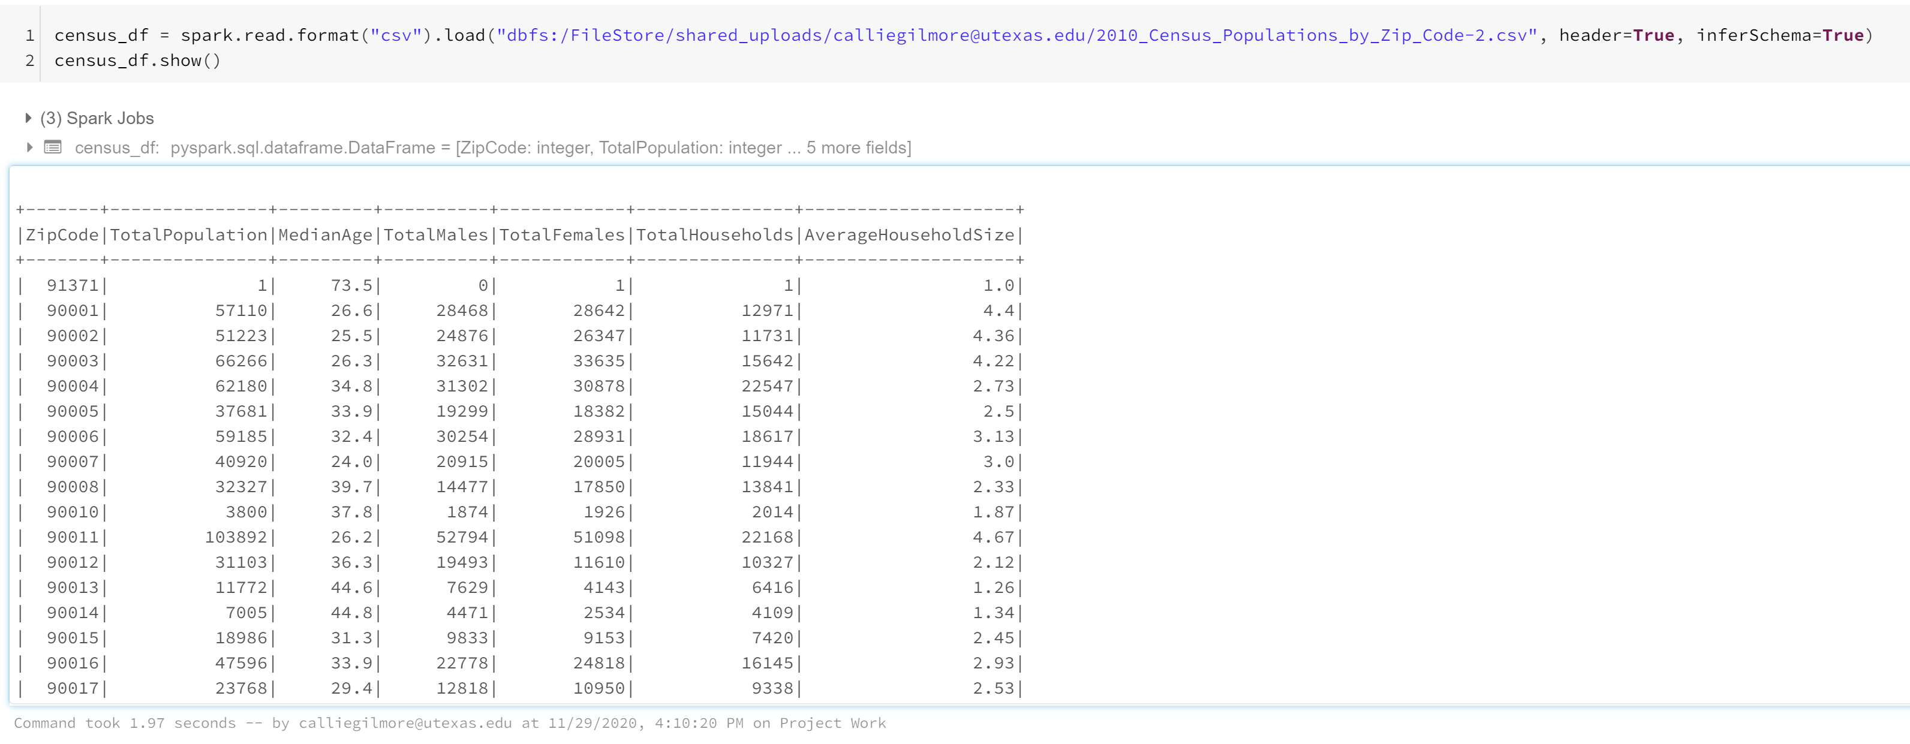

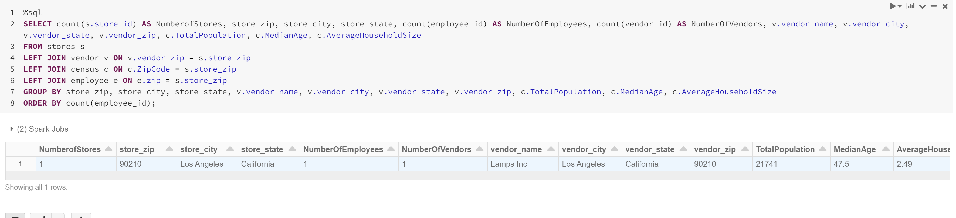

# **Analysis Patterns**

For our first analytical pattern, we decided to look at the number of stores and the number of employees by zip code. With only 1 data point, this is not very interesting. However, with multiple stores and employees in each zip code, this could help the Home Depot understand which zip codes are underserved either by number of stores or number of employees working at the stores. The proportion of employees to stores in each zip code is also important and could provide interesting information as well. Additionally, you could display this graph as a proportion of Total Zip Code Population by dividing these values by the Total Population. We chose not to display it this way because with only 1 data point, the proportion was very low and therefore the graph did not display anything.

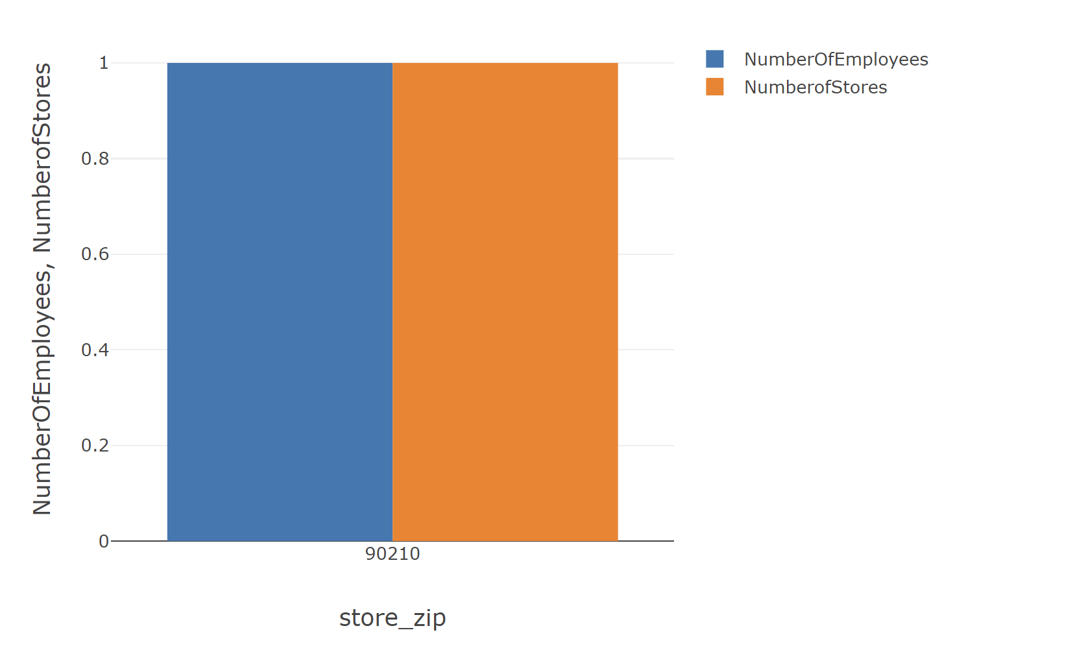

For our second analytical pattern, we utilized our census data to understand the proportion to males and females in each zip code. This could benefit Home Depot because they could utilize their customer data to have a target demographic. Based on this target demographic, Home Depot could then utilize the proportion of males to females in each zip code as well as the median age to open more stores in zip codes that have a higher proportion of the target demographic.

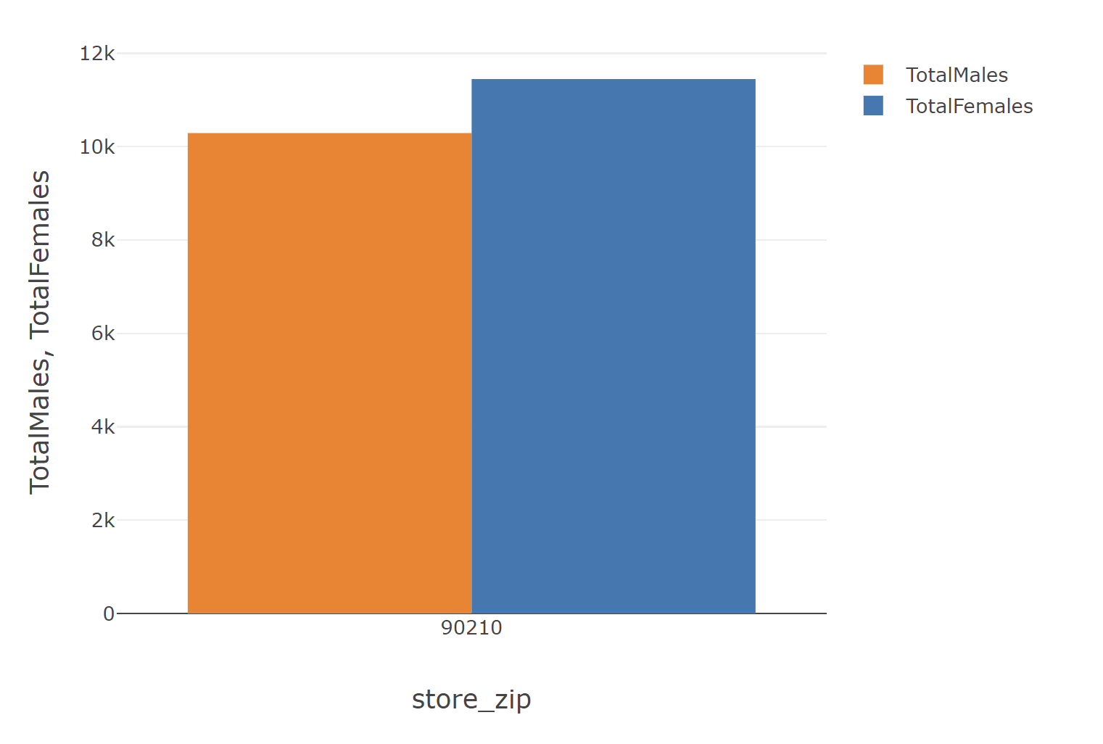

# **Questions**

## What did you learn?

Overall, this project was a very valuable learning experience. One of our biggest takeaways was simply how complex a company’s database environment can be. We were only looking at 3 applications and the data warehouse and ETL processes were still especially complications. This made us realize how complex a company’s environment is when they have hundreds of applications all producing data that needs to be stored. This also made us realize how valuable corporate structure and organization is when it comes to data. The company must have very clear organization and structure to store this data in ways that it can be accessed. Additionally, data without the ability to access it, is utterly useless. So, the corporate structure is also essential to gain any sort of insights from the data. While this project seemed complicated with only 3 applications, it is astounding to think of what these massive corporation’s data infrastructure looks like.

## What was the most valuable?

Understanding just how complex these environments can be is truly valuable, but our biggest takeaway is not only the importance of organization but also the best practices for keeping these databases organized, such as naming conventions. We ran into one issue where two of our constraint’s names were duplicate names, but the error message was not clear that this was happening. This was very hard to find and de-bug to figure out that that was the issue. Now this could have been avoided with more organized naming conventions from the beginning. So, creating very clear naming conventions and organized structures and making sure all members of the organization/team maintain these is a very valuable lesson to ensure the data is accessible and there are no issues with the database.

## How can you use this learning going forward?

This lesson on consistency and organization is one that can be applied to many different areas and will apply to every singly job that we have leaving this program. So, this is a lesson that we all take with us. Ensuring that there is consistency between naming conventions, processes, systems etc. But ensuring consistency is only half the battle. The other half is communicating this effectively to other members of the team and ensuring they follow those practices as well. So, one way we want to practice this going forward would be with detailed documentation as go so that nothing is every left out.

## What are additional opportunities for learning that this project did not capture?

I think some additional opportunities would be more applications of conduction analytical patters on the data. We got a little bit pf practice doing this in the project; however, it was difficult with such few data. It would be interesting to be able to see how we can utilize data lakes and other items as well to perform data analytics. Our current view is that you simply query the database, export the data as a CSV and import it into your tool of choice. While this is a fine method, there are other ways to analyze the data from this format and it would be cool to learn that.

## How can we change this project to capture these opportunities?

One way that this could be done was that if the data were provided. I understand that this causes difficulty as we are creating the ERDs and DDLs. Maybe the project can we be in 2 parts: the first part as we did it where we create the ERDs, DDLs, Data Warehouse, ETL and Data Lake and the second part with given data and a given data lake and we could run analytical patterns and processes on the given data lake. Or simply have a class day where we could spectate someone performing these types of activities. Overall, this was still a very valuable learning experience.